CASE STUDY PYSPARK (2-08-2025)

from pyspark.sql import SparkSession

from pyspark.sql.functions import col, count, max as max_, min as min_, sum as sum_

# Start Spark session

spark = SparkSession.builder.appName("Online Banking Analysis").getOrCreate()

# Load datasets

loan_df = spark.read.csv("/content/loan.csv", header=True, inferSchema=True)

credit_df = spark.read.csv("/content/credit card.csv", header=True, inferSchema=True)

txn_df = spark.read.csv("/content/txn.csv", header=True, inferSchema=True)

# Show schema just to verify

loan_df.printSchema()

credit_df.printSchema()

txn_df.printSchema()

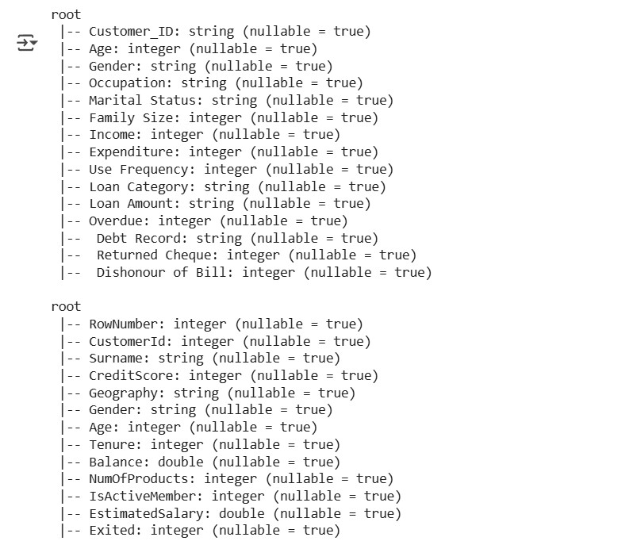

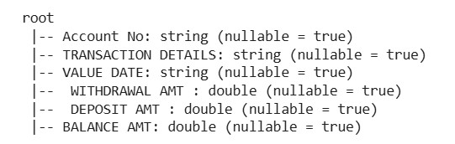

#show tables

loan_df.show(5)

credit_df.show(5)

txn_df.show(5)

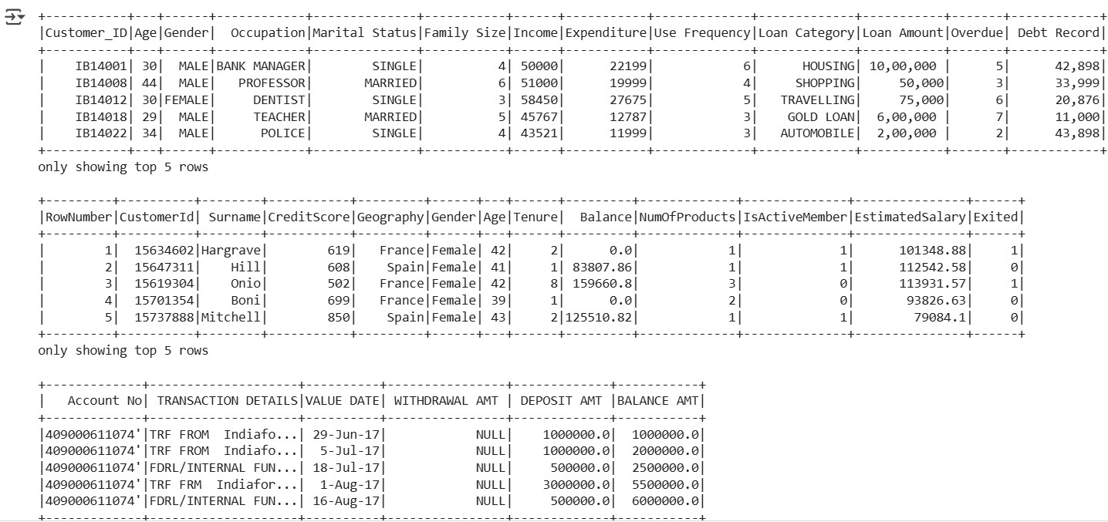

#Loan data use cases

print("\n# Number of loans in each category:")

loan_df.groupBy("Loan_Category").count().show()

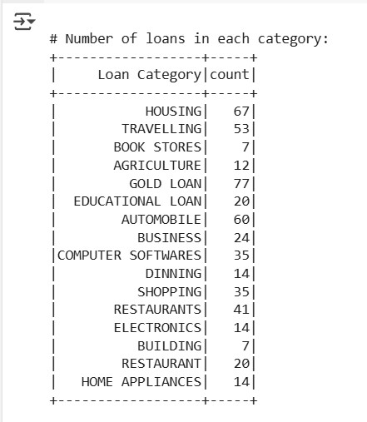

print("\n# Number of people who have taken more than 1 lakh loan:")

loan_df.filter(col("Loan_Amount") > 100000).select("Customer_ID").distinct().count()

output:

# Number of people who have taken more than 1 lakh loan:

0

print("\n# Number of people with income greater than 60000 rupees:")

loan_df.filter(col("Income") > 60000).select("Customer_ID").distinct().count()

output:

# Number of people with income greater than 60000 rupees:

198

print("\n# Number of people with 2 or more returned cheques and income less than 50000:")

loan_df.filter((col("Returned_Cheques") >= 2) & (col("Income") < 50000)).select("Customer_ID").distinct().count()

output

# Number of people with 2 or more returned cheques and income less than 50000:

136

print("\n# Number of people with 2 or more returned cheques and are single:")

loan_df.filter((col("Returned_Cheques") >= 2) & (col("Marital_Status") == "Single")).select("Customer_ID").distinct().count()

output:

# Number of people with 2 or more returned cheques and are single: 0

print("\n# Number of people with expenditure over 50000 a month:")

loan_df.filter(col("Monthly_Expenditure") > 50000).select("Customer_ID").distinct().count()

output:

# Number of people with expenditure over 50000 a month:

6

print("\n# Number of members who are eligible for credit card:")

loan_df.filter(col("Eligible_for_CreditCard") == "Yes").select("Customer_ID").distinct().count()

output:

# Number of members likely eligible for credit card (Income > 50k, Returned Cheque = 0):

22

# CREDIT CARD DATA USE CASES

print("\n# Credit card users in Spain:")

credit_df.filter(col("Country") == "Spain").select("Customer_ID").distinct().count()

output:

# Credit card users in Spain:

2477

print("\n# Number of members who are eligible and active in the bank:")

credit_df.filter((col("Eligible") == "Yes") & (col("Status") == "Active")).select("Customer_ID").distinct().count()

output:

# Number of members who are likely eligible (CreditScore > 650) and active in the bank:

2655

#TRANSACTION DATA USE CASES

from pyspark.sql.functions import col, max as max_, min as min_, sum as sum_, to_date

# Step 1: Clean all column names (remove leading/trailing spaces and replace internal spaces with "_")

txn_df = txn_df.toDF(*[c.strip().replace(" ", "_") for c in txn_df.columns])

# Step 2: Cast numeric fields and parse date

txn_df = txn_df.withColumn("WITHDRAWAL_AMT", col("WITHDRAWAL_AMT").cast("double")) \

.withColumn("DEPOSIT_AMT", col("DEPOSIT_AMT").cast("double")) \

.withColumn("BALANCE_AMT", col("BALANCE_AMT").cast("double")) \

.withColumn("VALUE_DATE", to_date("VALUE_DATE", "dd-MM-yyyy"))

print("\n# Maximum withdrawal amount in transactions:")

txn_df.select(max_("WITHDRAWAL_AMT").alias("Max_Withdrawal")).show()

output:

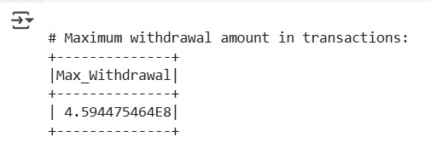

print("\n# Minimum withdrawal amount in transactions:")

txn_df.select(min_("WITHDRAWAL_AMT").alias("Min_Withdrawal")).show()

output:

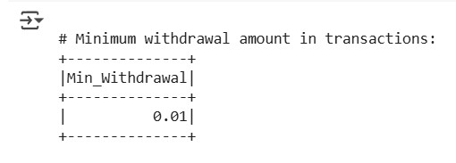

print("\n# Maximum deposit amount in transactions:")

txn_df.select(max_("DEPOSIT_AMT").alias("Max_Deposit")).show()

output:

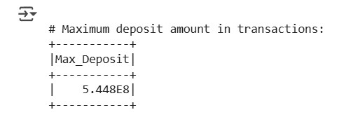

print("\n# Minimum deposit amount in transactions:")

txn_df.select(min_("DEPOSIT_AMT").alias("Min_Deposit")).show()

output:

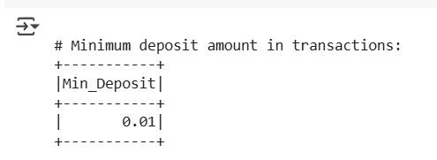

print("\n# Sum of balance in every bank account:")

txn_df.groupBy("Account_No").agg(sum_("BALANCE_AMT").alias("Total_Balance")).show()

output:

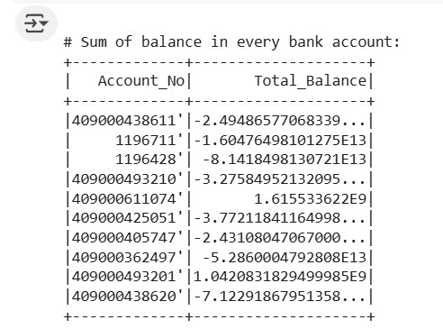

print("\n# Number of transactions on each date:")

txn_df.groupBy("VALUE_DATE").count().orderBy("VALUE_DATE").show()

output:

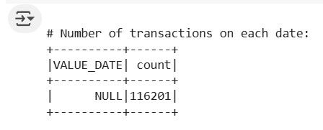

print("\n# List of accounts with withdrawal amount more than 1 lakh:")

txn_df.filter(col("WITHDRAWAL_AMT") > 100000) \

.select("Account_No", "WITHDRAWAL_AMT").distinct().show()

Output:

